Tessa Davis

Foundations of Programming-Python

16 March 2022

Assignment 08

Module 08 Knowledge Document

**Assignment**

The focus of this unit is object-oriented programming. As a whole, the assignment aims for us to see the ways in which we have already been using object-oriented programming as well as to add nuance to the concept.

**Discussion**

Key points from lecture:

* A class defines the architecture of the object. The builder initializes the blueprint and that creates the object.
* Classes have the data and functionality of the object. Then you create a particular instantiation.

Lab08-A

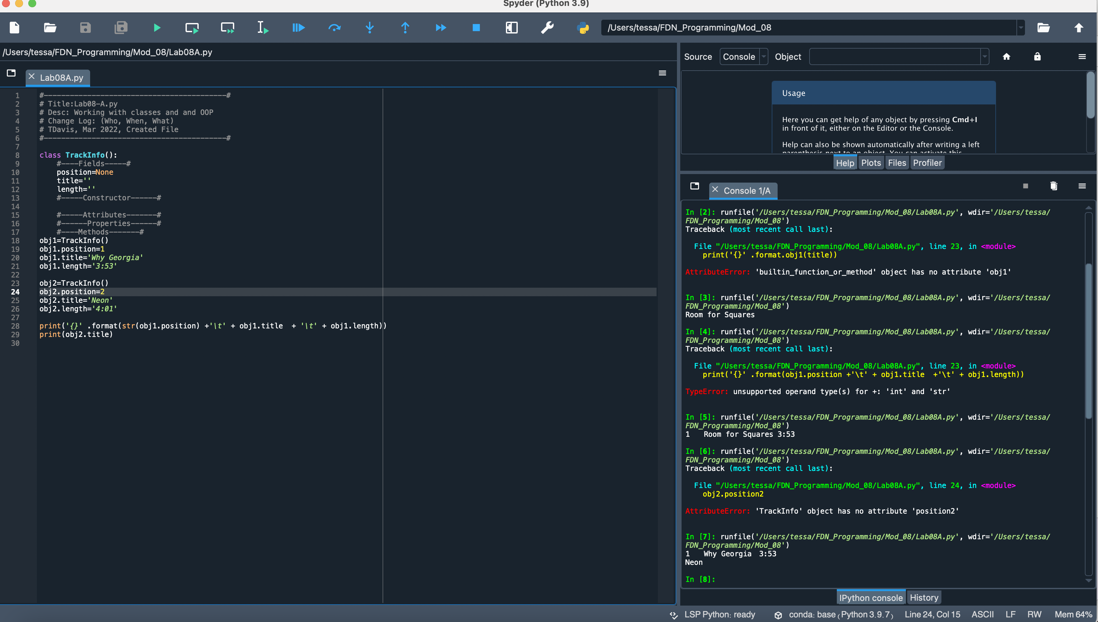

Figure Lab 08A Screenshot

This lab seemed fairly straightforward. As I understand it, the class level fields created are then defined by my entering the data in lines 19-26. The information was then saved as obj1, obj2, etc. I played with calling a specific field (e.g. obj2.title) and the entire object in my print statements. The functionality of obj.title feels similar to a key word in a dictionary.

Lab08-B

Using a constructor seems to be a significant time saver. Rather than having to go through the multi-step process to create the object as needed in Lab A, adding then constructor streamlines the entry. To instantiate an object, all that is required is passing the three values into the class function when called.

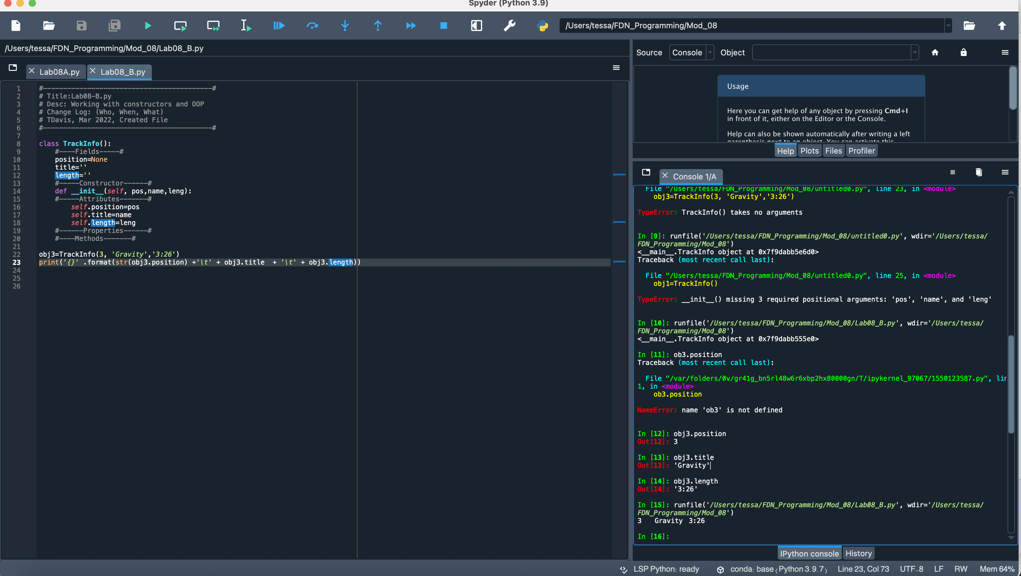

Figure Lab08B

Lab08-C

This lab demonstrated that Python will create implicit attributes and also highlighted the difference between fields—that apply throughout the class—and attributes that may be kept private. Despite not having defined the fields, the constructor function worked by essentially assuming the existence of the necessary attributes within the def __init__.

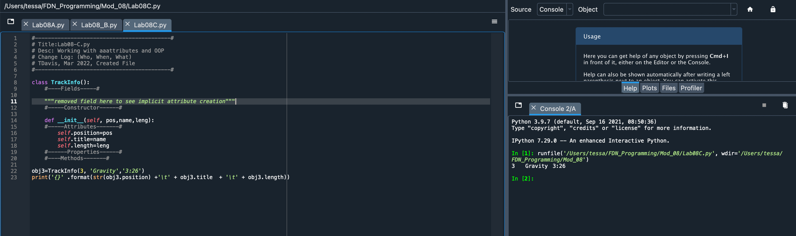

Figure Lab 0C

Lab08-D

As I understand the crux of this lab, it was to see how error handling and assigning of values can occur through the use of properties within a class. The getter helped define each parameter of the object and the setter allows us to control for errors, such as incorrect value types. I created two different versions of this lab. The second used private attributes. I tested the error handling and privacy and both seemed to be functional

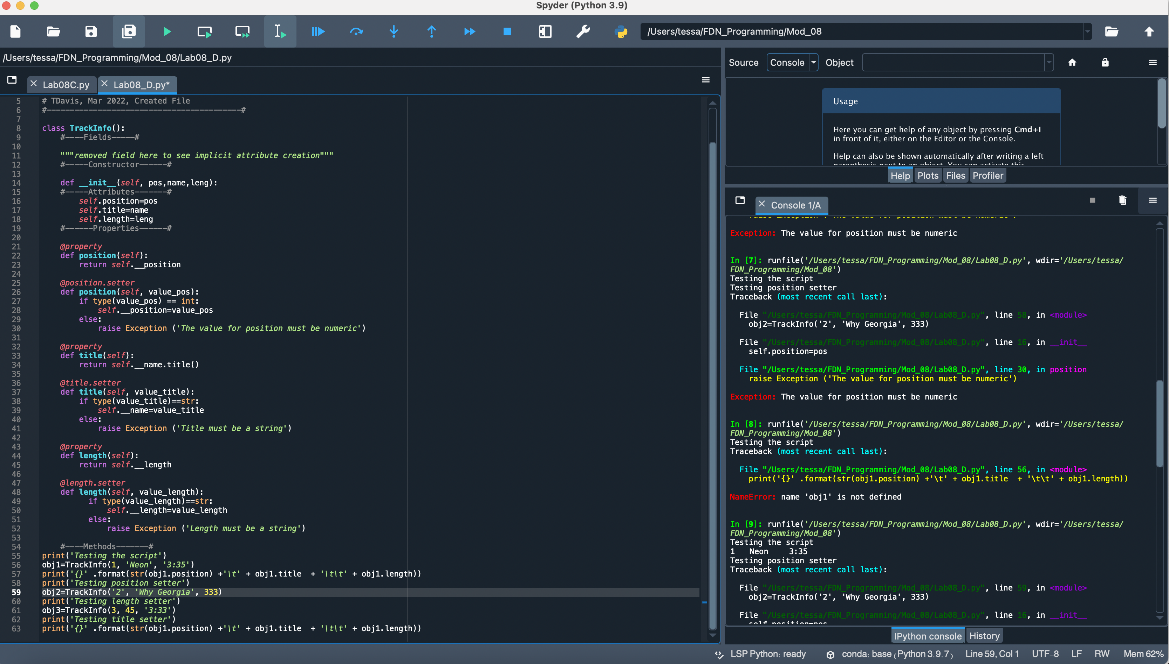

Figure Lab08_D Screenshot

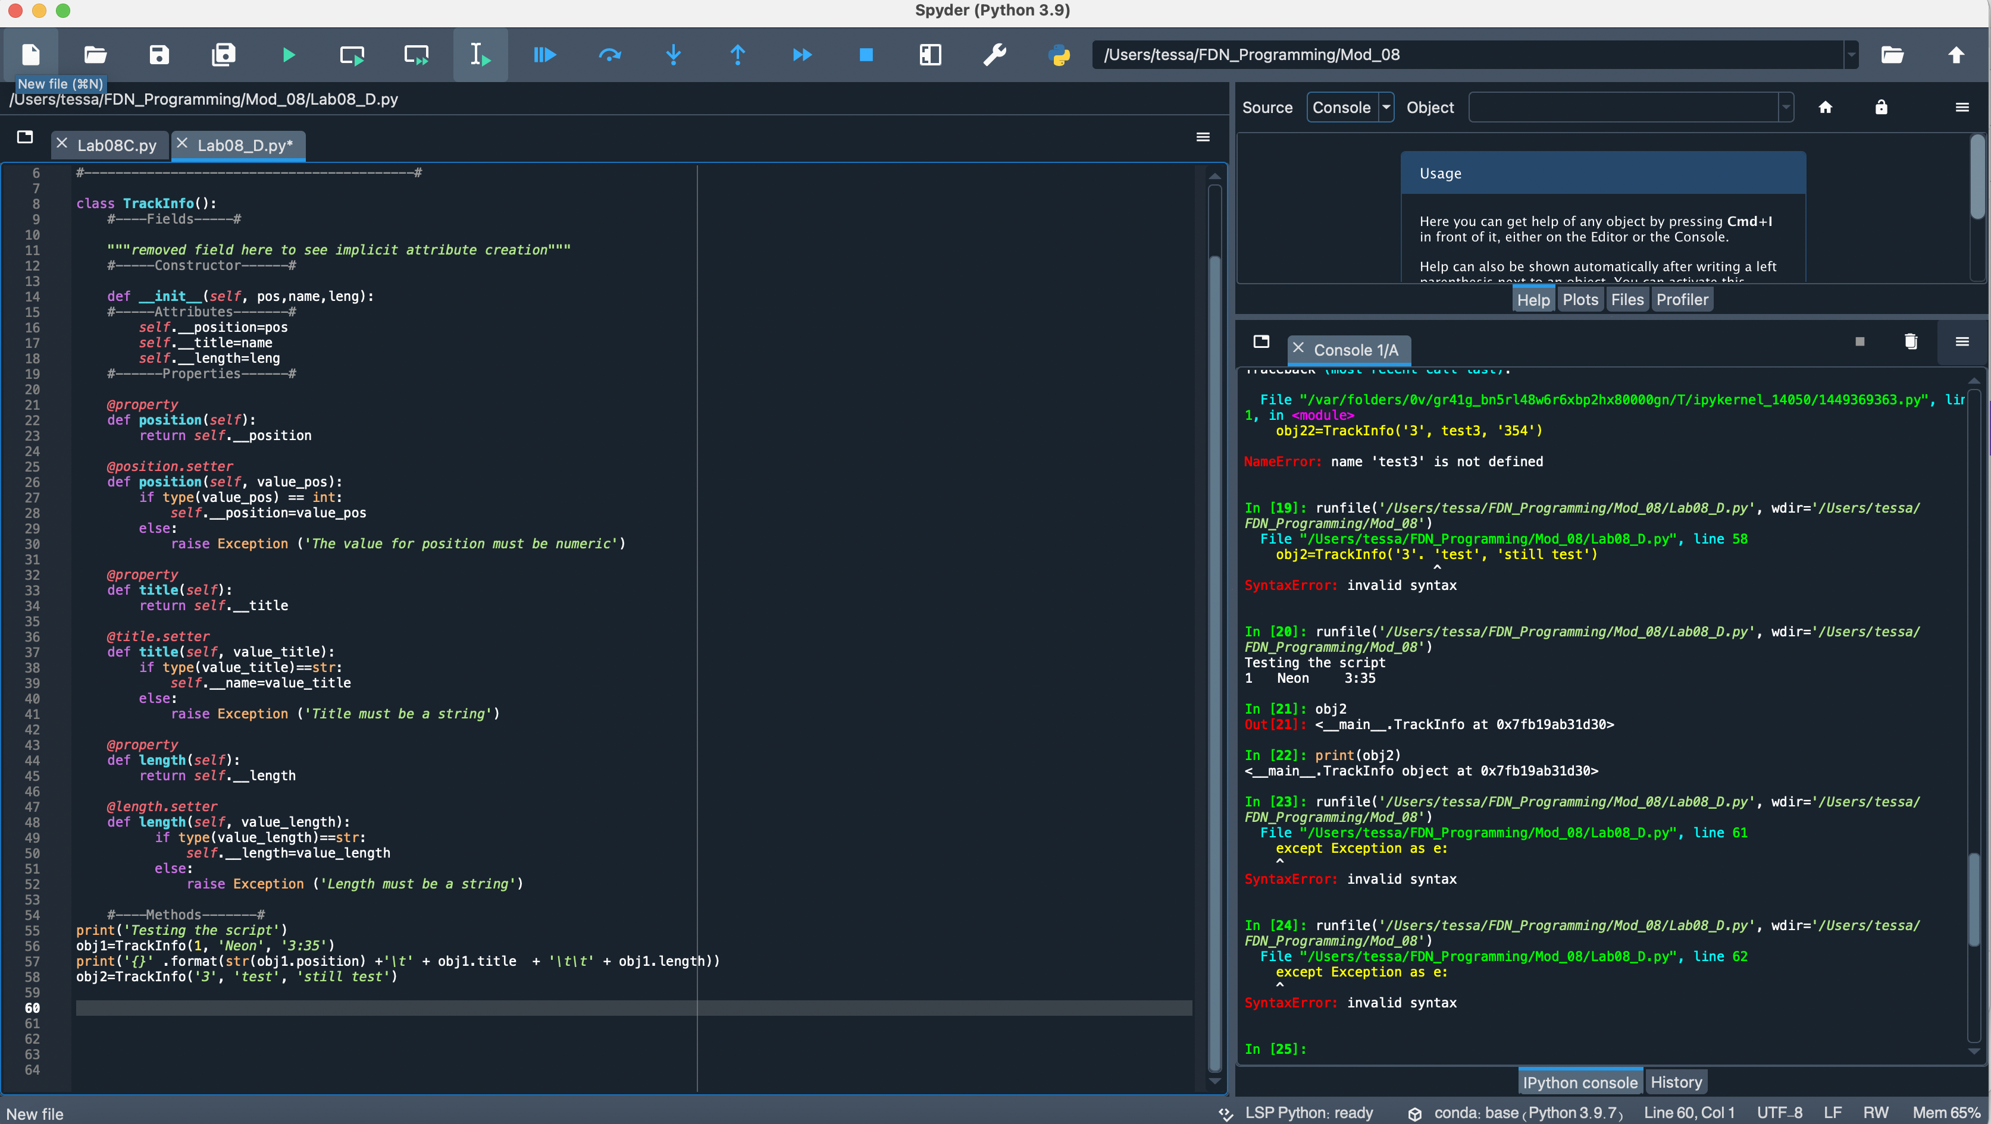

Figure Lab08_DV2 Screenshot

Lab 08-E

Lab 08 introduced defining our own methods. The __str__ method created formatted the objects created in a readable format. I did expect it to convert all data to a string but received an error in the print statement. I handled the conversion within the print statement. Am I incorrect that the __str__ automatically converts to a string?

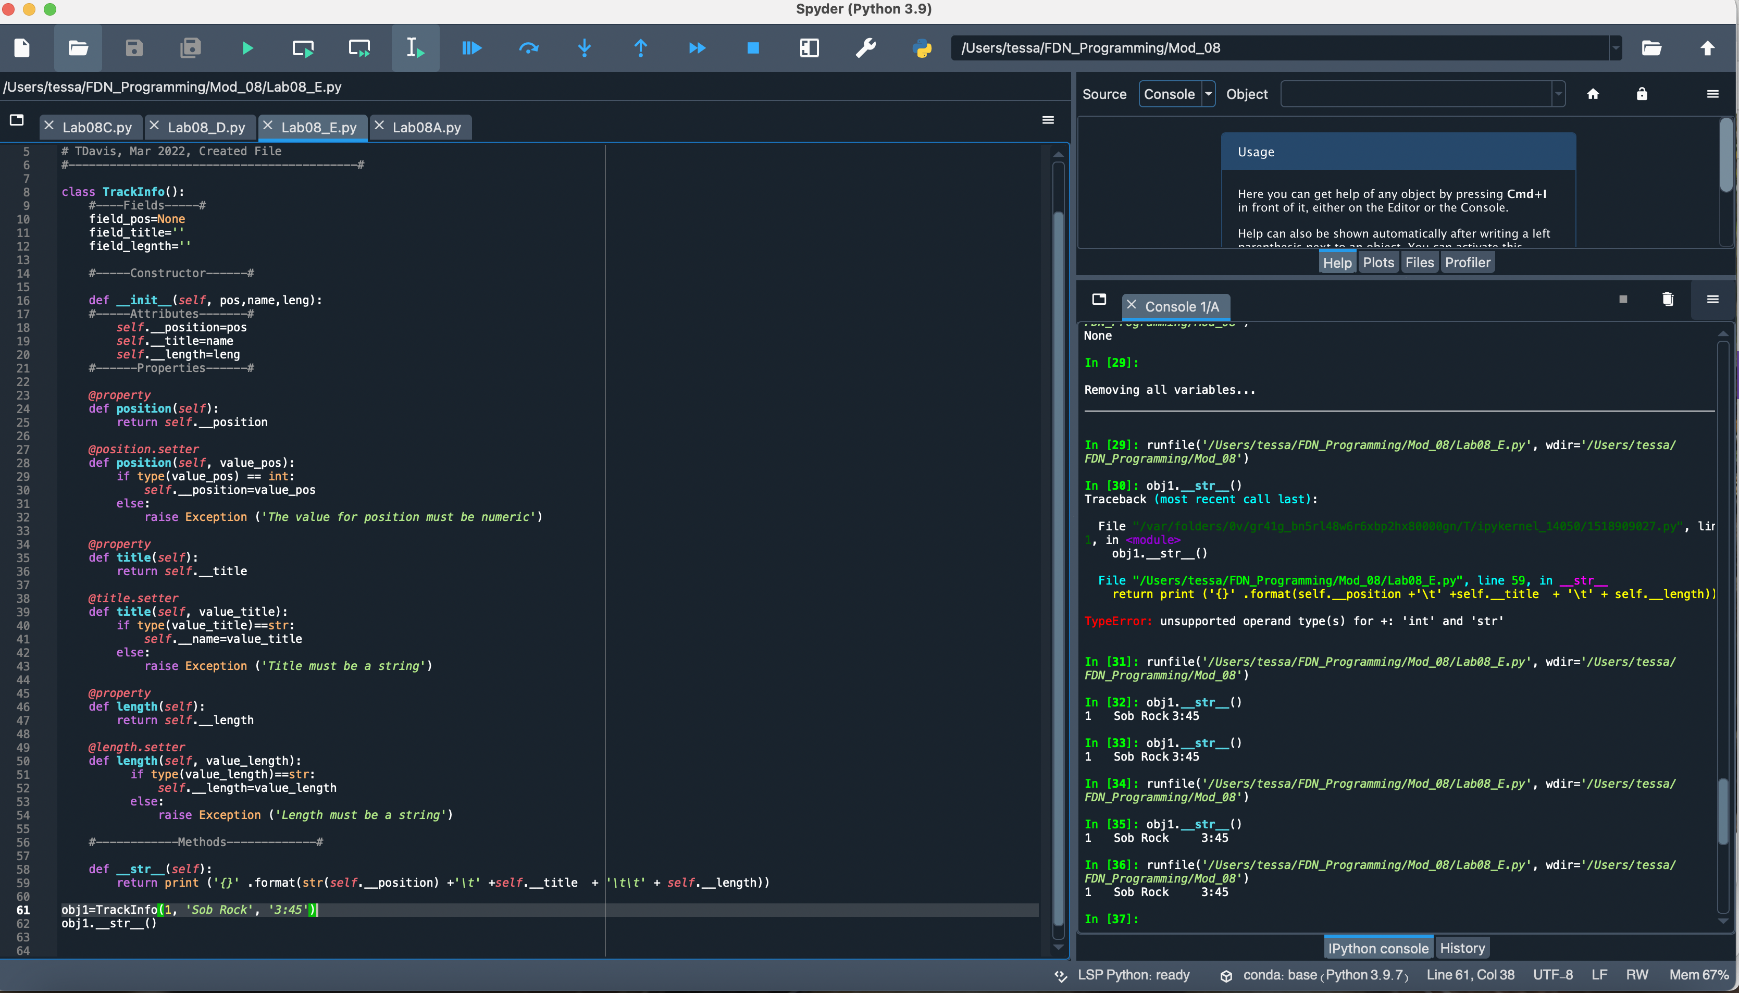

Figure Lab 08-E Screenshot

Assignment 08

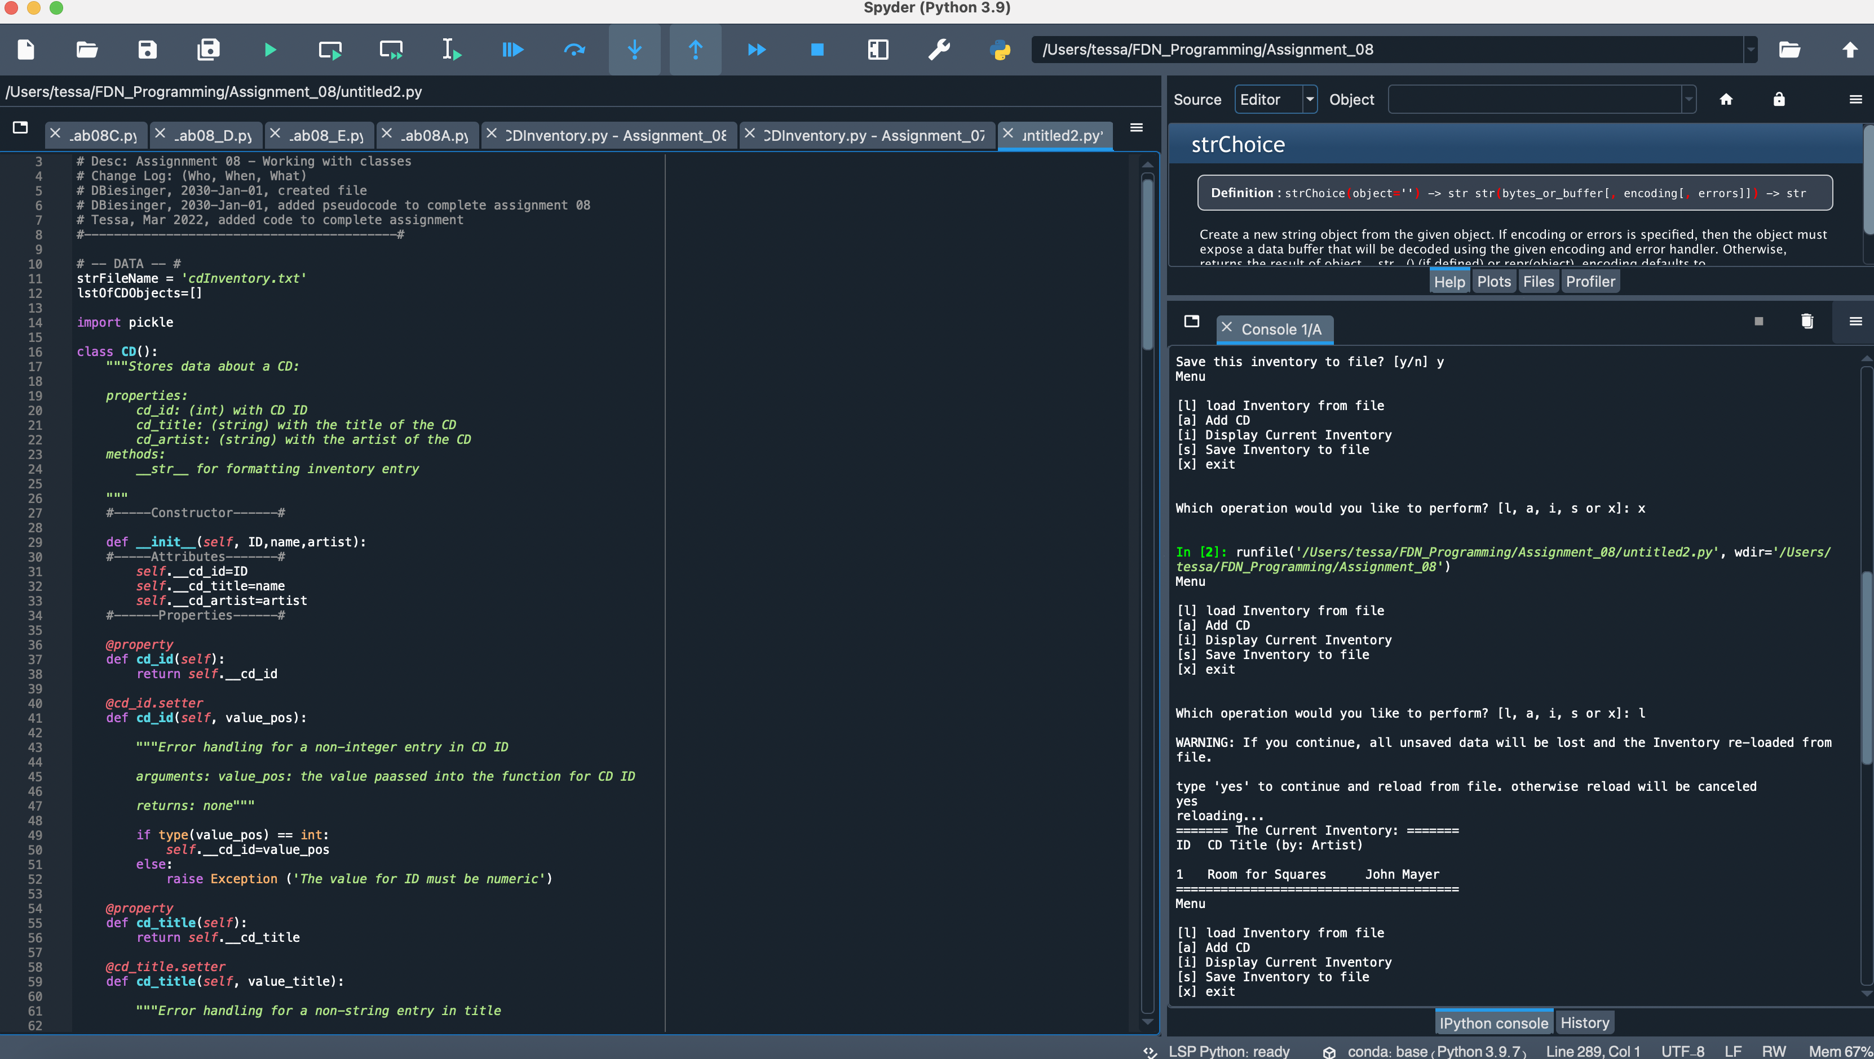

Figure Assignment 08 in Spyder

I was able to make use of code from Assignment 07 and the Module 08 labs to build out this assignment. Creating the CD Class seemed to flow fairly directly from the work for the Labs. I then modified code from CD Inventory.py for assignment 07 to work with the new class created in this assignment. The one aspect of functionality with which I struggled was getting the current inventory to display upon opening the program. I attempted to use IO.load and show_inventory but using the show_inventory created issues with the ‘a’ function. Specifically, I could no longer add an exiting entry, receiving an error that a None could not be appended. Even having been able to modify the code and feeling comfortable commenting out how it works, etc, I continue to be less clear on how/the extent to which this work differs from that of prior weeks.

Helpful resources:

<https://odsc.medium.com/handling-exceptions-in-python-object-oriented-programming-a3ab19dfda79>

<https://stackoverflow.com/questions/44196243/iterate-over-list-of-class-objects-pythonic-way>

Github Link:

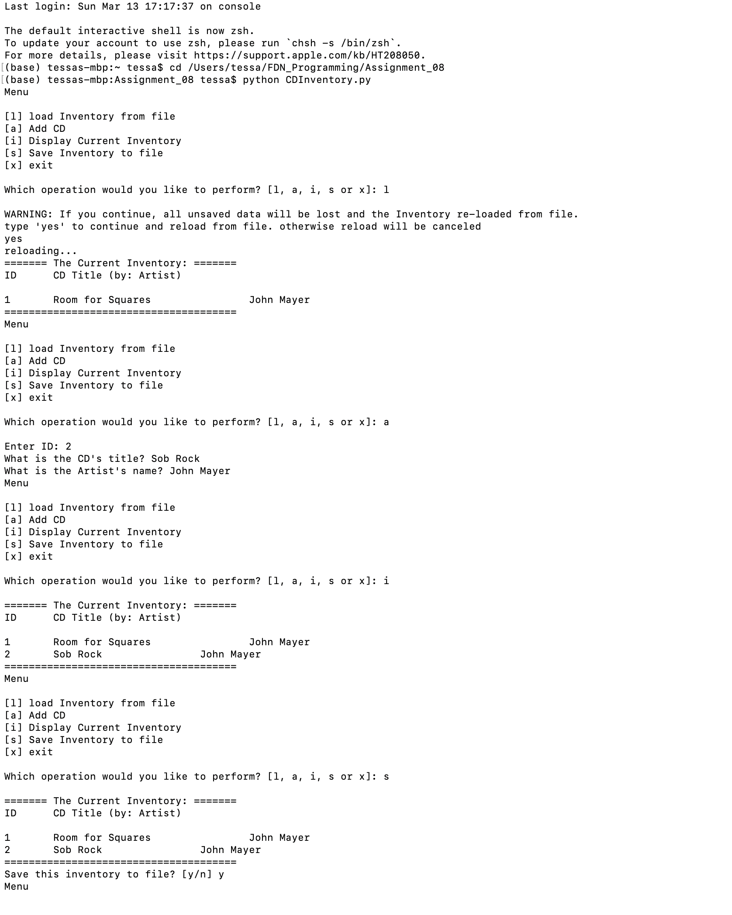

Figure Assignment 08 in Spyder

**Conclusion**

Though the labs, as a whole, went well I believe I am still struggling to see the forest for the trees. To go to a different metaphor used in class, I understand the idea that the class is the blueprint and the object is the particular house built. But in creating the assignment script, I struggled to see how what we were doing this week was all that different from the prior week, which has me concerned that I’m missing something.